Practicum No.10 Date:……….
Financial Feasibility – Case study

- Practical Significance

Financial feasibility assessment determines whether a startup idea is economically viable and sustainable. This practicum is designed to transition CSE, AIML, DSCS & DS students from conceptualizing a software-based idea to understanding its economic reality. For any tech start-up in domains like AI, data science, or software development, a financial feasibility report is a critical document that determines whether a business idea is economically viable and sustainable. This exercise immerses students in the financial planning process, teaching them to forecast costs, project revenues, and calculate key metrics like Break-Even Point (BEP) and Return on Investment (ROI). By creating this report for their own identified start-up, students develop a crucial entrepreneurial skill: the ability to scientifically evaluate and communicate the economic potential of a technical innovation. This bridges the gap between coding a solution and building a profitable business, preparing them for roles as tech founders, product managers, or innovation consultants who must justify project viability to stakeholders and investors.

This practicum exercise is expected to develop the following skills for the industry-identified competency.
- Develop a pitch deck, project proposals for small/medium scale startups logically and scientifically.
(As stated in the Course Structure)
- Apply financial principles to assess the viability of startup projects. (CDO)
- Interpret cost, revenue, and profitability indicators effectively. (CDO)
- Exhibit professional and ethical decision-making in financial planning. (ADO)

- Relevant CO(s) (As stated in the Course Structure)

- CO4. Design a suitable business model and formulate financial plans for the selected product/service.

- Practical Outcome (PrO) (As stated in the Course Structure)

- Present a financial feasibility report for the identified CSE, AIML, DSCS & DS start-up.

- Related ADO(s) (As stated in the Course Structure)

- Function effectively as a team member.
- Take responsible financial decisions aligned with entrepreneurial ethics.

- Minimum Underpinning Theory (Include relevant content & images for this practicum.)
Financial feasibility involves estimating whether a business can generate sufficient revenue to cover its costs and yield profit within an acceptable timeframe. It typically includes the following components:
- Capital Investment Estimation – cost of equipment, materials, licensing, and infrastructure.
- Operating Costs – recurring expenses such as raw materials, utilities, labor, and maintenance.
- Revenue Projections – expected income based on market size, pricing, and sales volume.
- Break-even Analysis (BEA) – determining when total revenue equals total cost.
- Profitability Ratios – metrics like ROI (Return on Investment) and NPV (Net Present Value).
- Sensitivity Analysis – evaluating how variations in cost or price affect profitability.
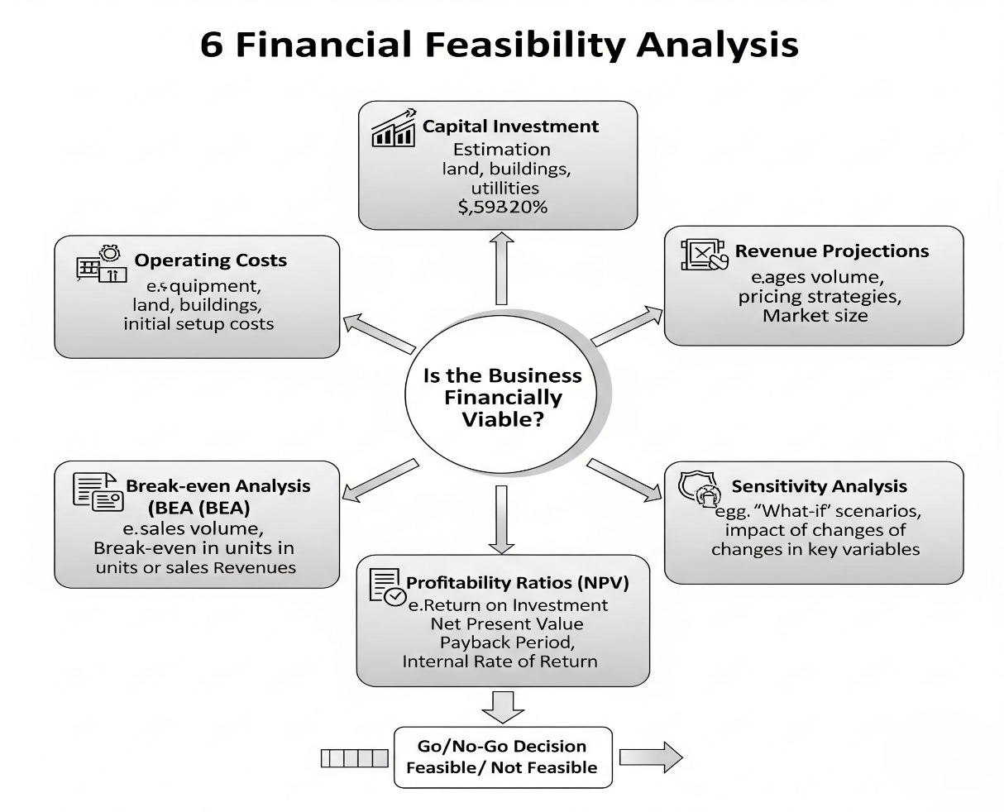

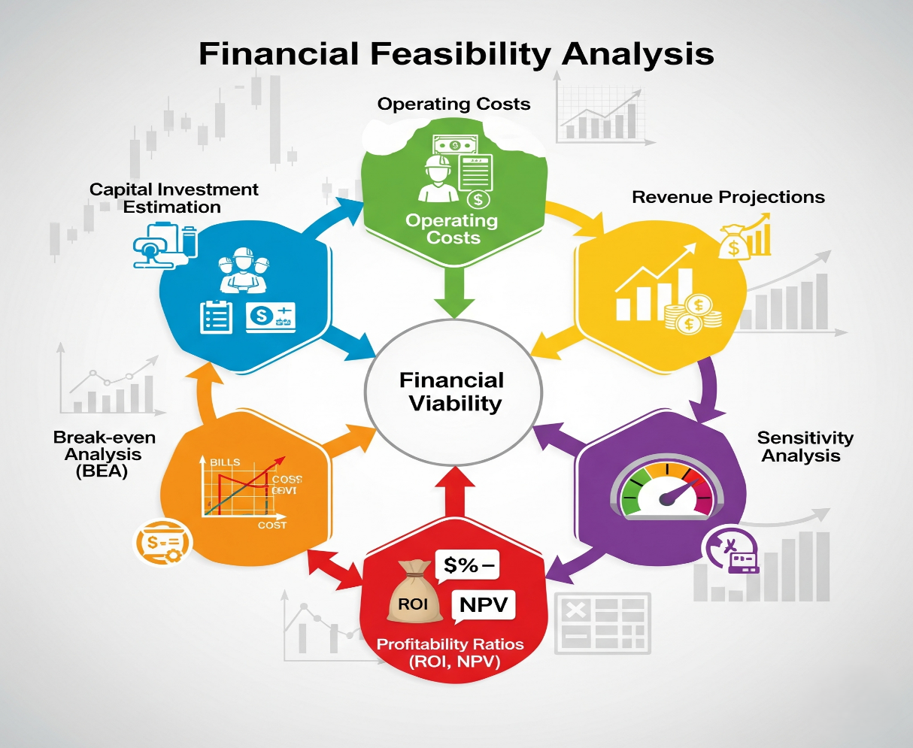

For software and AI start-ups, costs are often heavily weighted towards talent (salaries) and cloud infrastructure, while revenues are driven by scalable digital business models. Understanding financial feasibility equips engineering entrepreneurs to communicate effectively with investors, justify resource allocation, and plan sustainable growth.
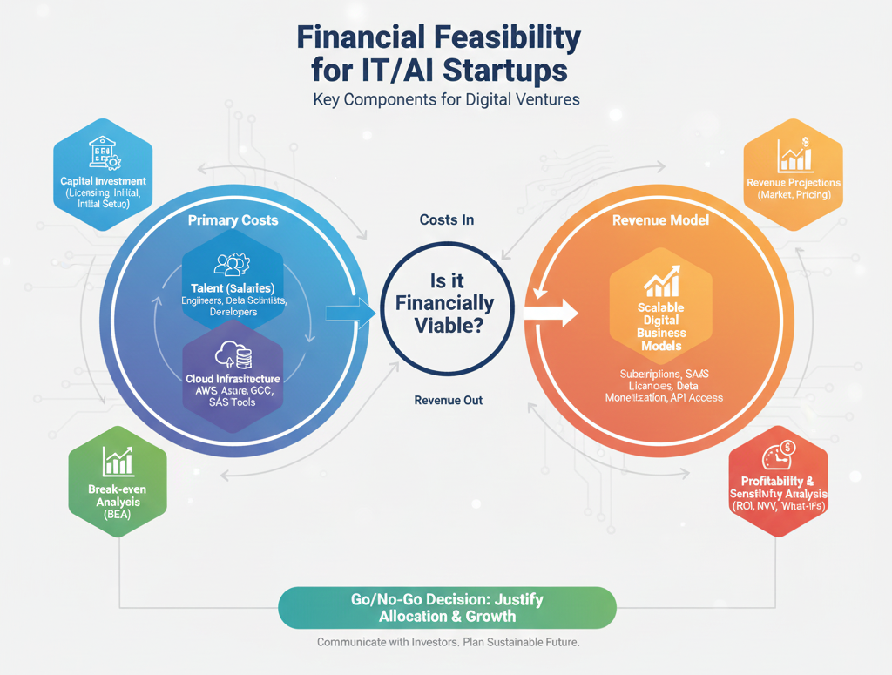

- Practicum Set-up/Circuit Diagram/Algorithm/Flowchart (Include probable photos of experimental set-up.)

Algorithm Steps:
- Start (Define Scope/Objective): Clearly state the financial goal being assessed (e.g., assessing viability over 3 years).
- Estimate Capital Investment: Calculate initial, one-time costs, primarily for licensing, initial hardware/software, and essential setup fees.
- Project Operating Costs: Focus heavily on the main recurring expenses for IT/AI: Talent/Salaries (e.g., data scientists, engineers) and Cloud Infrastructure (e.g., AWS, Azure, GCP costs).
- Forecast Revenue: Base projections on a Scalable Digital Model (e.g., subscription tiers, SaaS licensing fees, data monetization).
- Calculate Break-even Point (BEP): Determine the revenue or number of customers needed to cover all projected operating and capital costs.
- Perform Profitability Analysis: Calculate key metrics like ROI (Return on Investment) and NPV (Net Present Value) to assess long-term value.
- Conduct Sensitivity Analysis: Evaluate how profitability changes under different "what-if" scenarios, such as a 20% increase in talent wages or a 10% drop in subscription price.
- Feasibility Decision (Go/No-Go): Based on the analysis, make a formal decision on whether the venture is financially sound.
- End

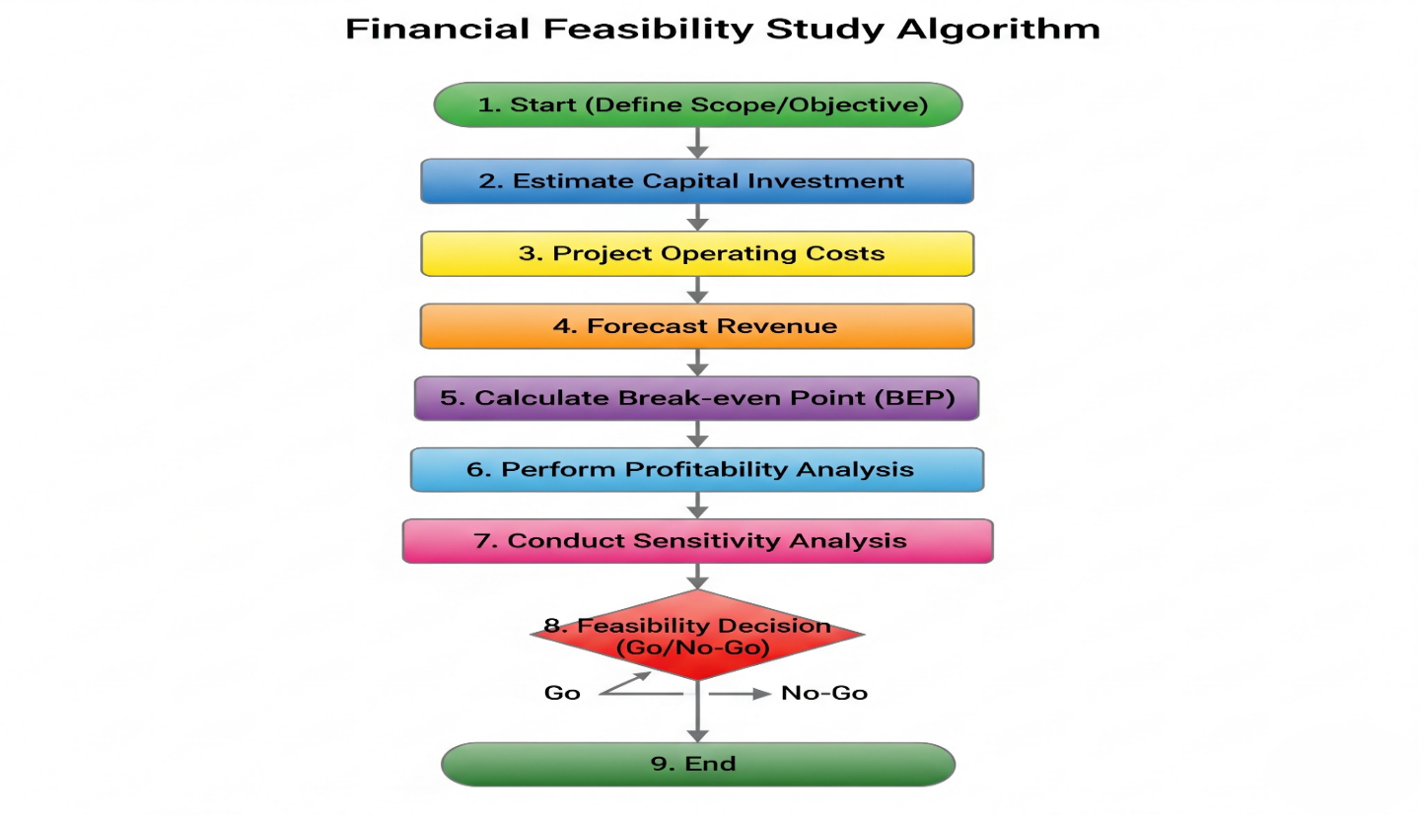

Classroom or computer-lab based activity with spreadsheet tools (MS Excel / Google Sheets).
- Resources Required

S. No. | Resource | Suggested Broad Specification | Quantity
1 | Laptop | i5 or above, MS Word / Google Sheets | 1
2 | Internet Access | For case study and cost estimation | shared
3 | Calculator | For quick verification | shared
4 | Sample Case Study | CSE, AIML, DSCS & DS -based startup | 1

- Safety Precautions

- Use realistic and justified financial data for calculations.
- Cite all sources used for cost or pricing estimates.
- Maintain accuracy and integrity in quantitative analysis.

- Procedure (Self-Instructional)

- Select a case study of a technology-based startup (CSE, AIML, DSCS & DS domain).
- Study the project background — product, target market, and technology scope.
- List all cost components, including:
- Fixed Costs (equipment, setup, R&D).
- Variable Costs (materials, labor, logistics).
- Overheads (marketing, maintenance, taxes).
- Estimate total capital investment required for initial setup.
- Prepare a projected income statement for 3–5 years showing revenue, expenses, and net profit.
- Calculate the Break-Even Point (BEP) using:
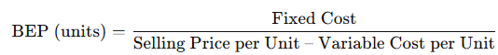
- Compute ROI or Payback Period to assess profitability.
- Conduct sensitivity analysis by modifying cost or price assumptions (±10%) to observe impact.
- Interpret results to determine whether the startup is financially feasible.
- Prepare a Financial Feasibility Report (3–5 pages) including all calculations, graphs, and conclusions.

- Actual Resources Used (To be filled by the students)

S. No. | Name of Resource | Broad Specifications |  | Quantity | Remarks  (If any)
S. No. | Name of Resource | Make | Details | Quantity | Remarks  (If any)
- Actual Procedure Followed (To be filled by the students)
  - ……………………………………………………………………………………………………
  - ……………………………………………………………………………………………………
  - …………………………………………………………………………………………………

- Observations (To be filled by the students)

S.  No. | Observations | Remarks
1 | Key financial parameters used (fixed cost, variable cost, selling price)
2 | Observed trends in break-even or ROI values
3 | Sensitivity outcomes based on cost variations

- Results/Observations (To be filled by the students)
- ………………………………………………………………………………………………………………………………………………………………………………………………
- ………………………………………………………………………………………………………………………………………………………………………………………………
- Interpretation of Results (Students to state the meaning of the above-obtained results/observations)
…………………………………………………………………………………………………….
…………………………………………………………………………………………………….
…………………………………………………………………………………………………….

- Conclusions (Students to draw conclusions (or take decisions) based on the interpretation of results) ………………………………………………………………………………………………………………………………………………………………………………………………………………………………………………….………………………………………………………………………………………...………………………………………………………………………
- Suggested Practicum Related Questions:

Note: Below are a few questions related to industry-specific higher-order thinking skills (HOT) that teachers must use to ensure students achieve the predetermined course outcomes.
- Evaluate how the break-even point reflects startup risk.
- Analyze the relationship between pricing strategy and financial sustainability.
- Compare different funding models (bootstrapping, venture capital, government grants).
- Propose measures to reduce operating costs without compromising quality.
- Critique how cost estimation inaccuracies affect decision-making.
- Design a sensitivity test to analyze the effect of demand fluctuations on revenue.
- Justify how realistic financial planning influences investor confidence.
- Predict how scaling up production might alter the cost structure and profitability.

- References / Suggestions for further reading

- MSME Startup Funding Handbook (2024–25).
- AICTE IDEA Lab Grant Guidelines.
- Startup India Resources – https://www.startupindia.gov.in.
- BIRAC & DST Funding Schemes (2024–25).
- Suggested Assessment Scheme

The performance indicators given serve as a guideline for assessing the ‘process-related skills/LOs’ (marks to be awarded in real-time in the laboratory by the faculty member, as these cannot be measured after the practicum is over) and ‘product-related skills/LOs’

Note: The weightage for the process-related skills and product-related skills will change depending on the PrO, COs, and the competency related to the concerned course.

Performance Indicators |  | Maximum Marks | Marks Obtained
Process-related Skills: 18 Marks - 60%
1 | Collect realistic cost and revenue data. | 6
2 | Work effectively as a team during case analysis. | 5
3 | Apply correct formulas and reasoning in calculations. | 4
4 | Demonstrate ethical and professional reporting. | 3
Product-related Skills: 12 Marks - 40%
1 | Complete detailed financial analysis with logical accuracy. | 3
2 | Interpret results using graphs or tables effectively. | 2
3 | Draw justified conclusions on financial feasibility. | 3
4 | Conclusions. | 2
5 | Practical related questions. | 1
6 | Present the final report with clarity and format compliance. | 1
Total |  | 30

To be filled by Student:

S.No. | Name of the Student | Register No.
1

To be filled by the Faculty Member:
Marks Obtained |  |  | Name and Designation of the Faculty Member | Date of Evaluation
Process-Related Skills  (18) | Product-Related Skills (12) | Total  (30)

